THEME: POPULATION OF POLAND
TOPIC: RELIGIOUS AND EDUCATIONAL STRUCTURE OF THE POPULATION OF POLAND
FORMS: frontal, individual, groups, pairs, project, problem
METHODS: explanation, conversation, photo, work, projection, debate, map, work observation, brainstorm, debate, paper work, discussion, demonstration , role-play, text analysis
LESSON TYPE:
• introduction
• acquisition
• revision
• knowledge testing
• evaluation (knowledge testing)
• writte, oral examination
• evaluation (written examination)

CORRELATION: ethics, history, ICT
LESSON GOALS Students:
- understand national and cultural affiliation and the influence of European and Polish culture on different nations,
- can explain the religious structure of the poupulation of Poland,
- can explain the educational structure of the poupulation of Poland,
- understand the integrity of spatial issues and are familiar with some of their own possibilities for active participation.

MOTIVATION:
The teacher reads the article of the Constitution of Poland, which speak of freedom of conscience and the prohibition of incitement to discrimination and hatred and the prohibition of incitement to violence and war. Students are directed to the graphical representation of the religious structure of the population. The teacher leads a conversation about the importance of these two articles. Students justify why it is important that these human rights are written in the constitution. The teacher tells the students that we will talk about the religious and educational structure of the population.
TEACHER'S ACTTIVITY | STUDENTS' ACTIVITY
Direct the students to take a look in their students' books at the graphical presentation of population of Poland according to religion. Teacher gives instructions for analysis and leads the conversation.  . | In pairs students analyse the graphical representation and they come to the conclusion, that the largest share belongs to the Roman Catholic religion, followed by Orthodox and Protestant and ateists
Students are divided into 4 groups, religion and analysis instruction is assigned to each group. | In groups they debate about: - the impact of religion on everyday life in each religion, - what is the real freedom of religion choice in Poland, - are they themselves tolerant of other religions, they write their findings in their notebooks, A selected pupil presents his groups’ findings, an open discussion follows.
The teacher plays a video on refugees in Europe: https://www.youtube.com/watch?v=V91JaIDqAc in give instructions for analysis. | While watching the video students pay attention to: - the reasons for the flight of people from their homeland, - Europe's response, - Poland's response, - how to accept Muslim refugees in class. The groups debate on refugee issues in Europe and Poland.
The teacher directs the students to focus their attention to the graphical representation of the educational structure of the population in their students’ books. The teacher gives instructions for analysis and lead the conversation | Students in groups analyse the graphical representation and determine how the educational structure changed over time. They conclude about the differences in education between rural areas and cities in the past and today. A selected pupil presents his groups’ findings.
The teacher encourages the students to think about the influence of educational structure to the economic development of the country | In groups they determine that the educational structure has a significant impact on the economic development of the country. The findings are recorded in their notebooks.
The teacher presents GNU PSPP - a program for statistical analysis of sampled data 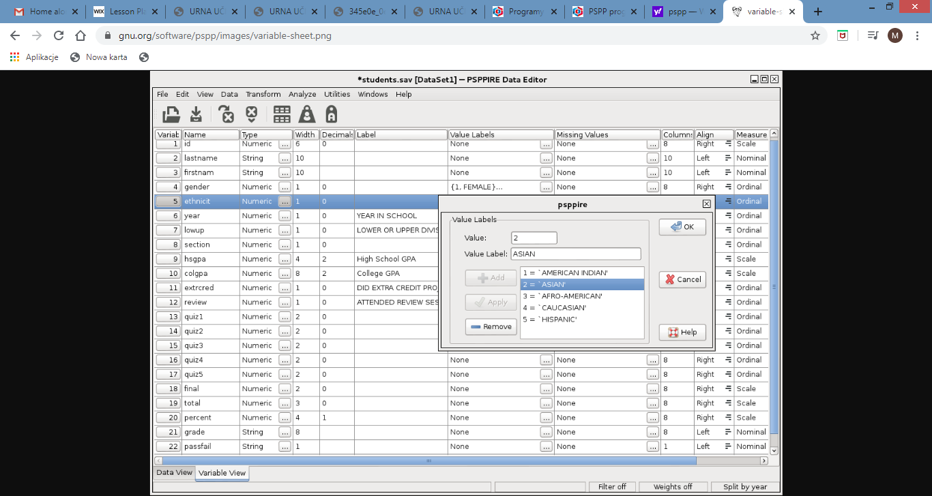 | Students prepare an analysis of present refugee situation in different European countries and its forecast for the next years (on the basis of Internet sources)

REVISION The learning material is consolidated with these core questions:
Which religions have we got in Poland?
Which religion prevails?
Where in Poland there are members of different religious communities? Why there?
Explain how the educational structure of the population changed over time.
Why is it important for a country to have an educated population?

