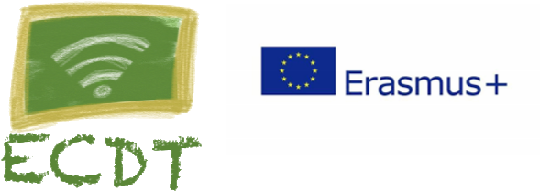

2018-1-EL01-KA229-047666_5
Escape Classroom – Digital Turn

MONIKA URBAŃSKA-WOJTACHA, ENGLISH TEACHER

SCENARIO

TITLE: Historical Pen Pals
SUBJECT: English/History/Science/Geography
CLASS: 6th grade and up
NUMBER OF STUDENTS: 18
TOTAL LEARNING TIME: 90 min.

TEACHING OBJECTIVES AND EXPECTED RESULTS:
At the end of the scenario students are expected to:
- Develop creative writing skills in the process - personalize history class
- Develop reading for gist and for detail on the topic of biographies
- Locate, collect, analyse and evaluate sources of scientific and historical information and use them in solving problems and taking actions
- Value scientific research
- Present and practise new vocabulary related to the topic
- Practice cooperating with each other
- Use digital tools to present their work and gather information
BRIEF DESCRIPTION

Warm up:
Going around the class students take it in turns to add three words to the story stem. Teacher starts with the words: Yesterday I went …
Pre-writing:
- Students watch the stories of Marie Skłodowska-Curie and Christpher Columbus.
https://www.youtube.com/watch?v=w6JFRi0Qm_s
https://www.youtube.com/watch?v=ThZj9TEMwgE
- Students are divided into two groups. The first group read the information about Marie Skłodowska-Curie and the second group about Christpher Columbus.

https://images.saymedia-content.com/.image/cs_srgb,dpr_1.0,q_80/MTY2NTQ0MjY5NjUyMjcyMzUx/mariecurie_facts_desktop.jpg
http://www.bbc.co.uk/history/historic_figures/curie_marie.shtml
http://www.bbc.co.uk/history/historic_figures/columbus_christopher.shtml

- Students check the meaning of words written by the teacher in an online dictionary (key words)
Writing:
Each student takes the role of a historical figure and writes with the use of Word program to a classmate about events he or she faced. Drawing on resources such as the videos and texts, the exercise allows the writer to process content from different and relevant subjects. Let’s say a student takes the role of Maria Skłodowska-Discovery. He or she can write about the radium and polonium discoveries, building knowledge of chemistry and physics in the process.
Post-writing:
- Re-read your story, make sure sentences make sense.
- Eliminate "fluff" (unnecessary or redundant details).
- Proofread for spelling, vocabulary, grammar (checklist).
- Edit your paper (peer-editing, post-teacher editing).
- Share with audience (website, print, etc.).

