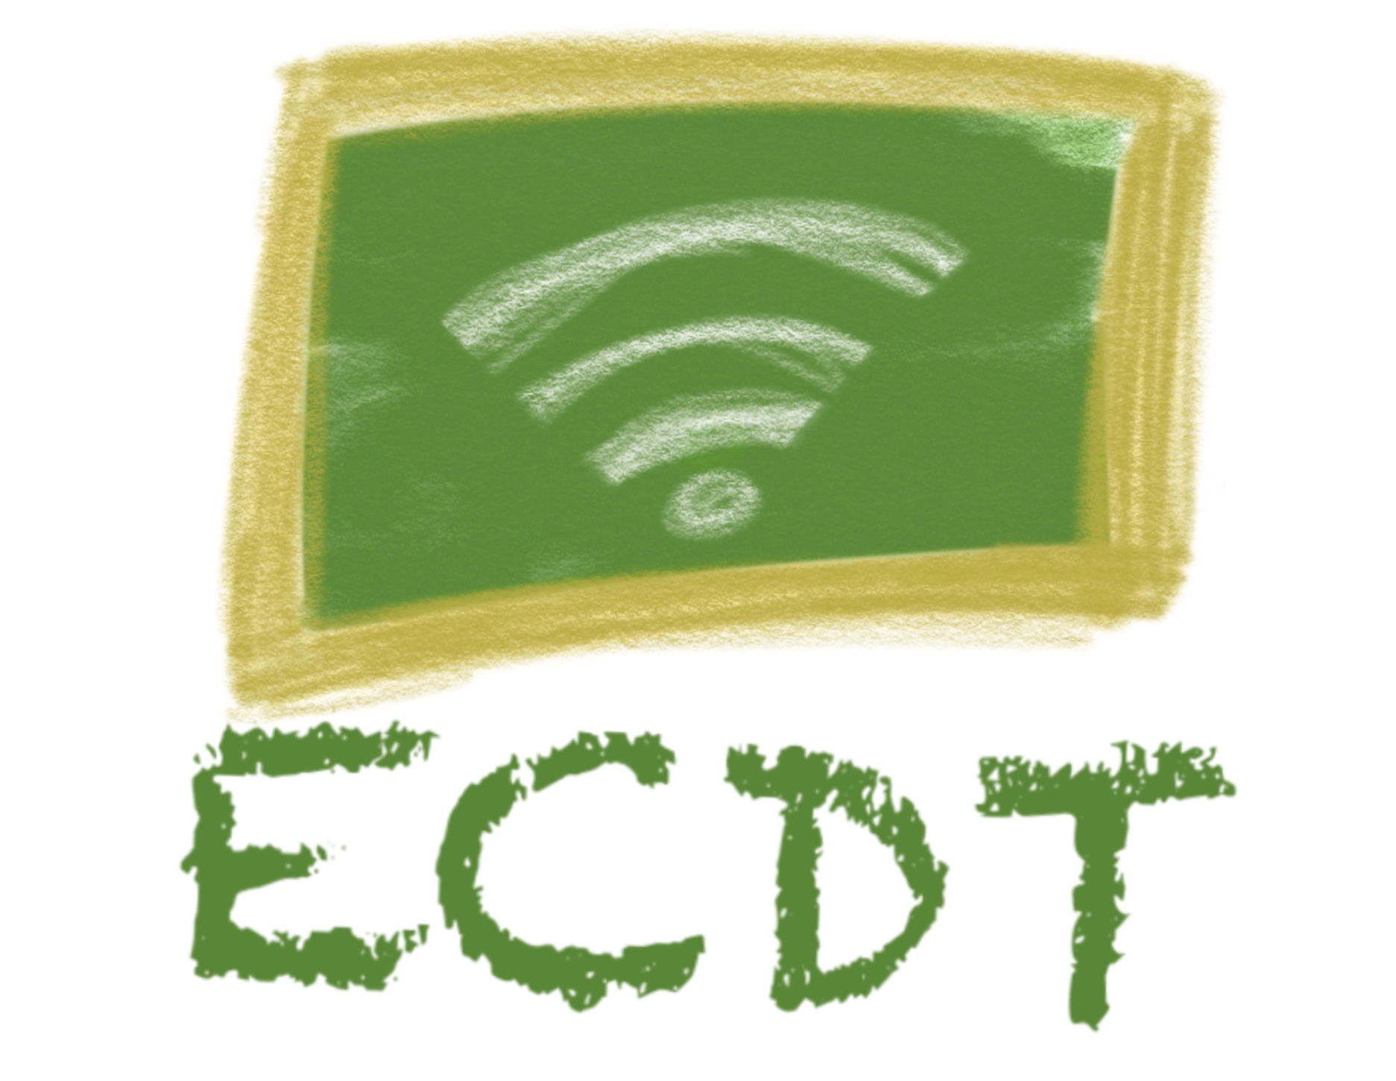LITHUANIA
Vilnius, Grigiskės “Sviesos“ gymnazium
Jurate Atkociuniene , English teacher
SUBJECT: English Language
CLASS: 7 th grade, aged 13-14
TIME : 50-60 min
Lesson plan
Topic : US History. Christopher Columbus
Aims:
- to learn about the great explorer
- to develop students‘ speaking skills
- to enrich vocabulary
Expected results:
at the end of the lesson students will be able to tell their friends at least 5 – 8 sentences about Christopher Columbus using the key words
Before the lesson | Before the lesson at home students had to watch a video 3.49 min  https://www.youtube.com/watch?v=hUNIbuda6Z0
Lead in 10 min  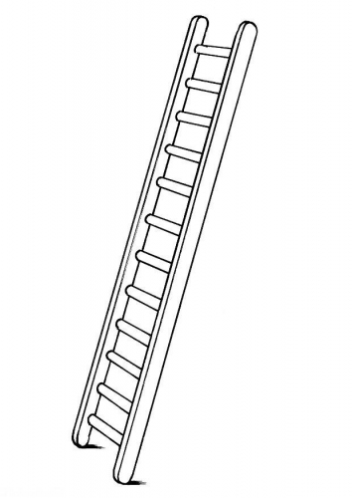 | Students listen to music „Music from the time of Ch.Columbus“ https://www.youtube.com/watch?v=tqAoaOttygo  On the smartboard students see the portrait of Ch.Columbus, a ship, a map with a route of Ch.C.  They are asked to share the information they recall from the video.  Students are shown a self assessment ladder and they mark their level of knowledge about Ch.Columbus at the beginning of the lesson.
20-25 min | Before analysing the text the teacher writes the key words on the whiteboard and Ss match them to the definitions.  For more specific information Ss listen and read the text on p.56 e-book, projected on the smartboard.  The teacher asks to find and say the sentences with the new words.  Then the teacher asks several questions to check if they understood the text:  Where was he from? What was his passion? What was the reason of his voyage? What problems did he face?Why did he call the people on the discovered island the Indians? What things did he bring back from his first voyage? Did he understand the importance of his voyages? ( The Ss can see the questions on the board)  Then students play kahoot to self assess their knowledge  https://create.kahoot.it/details/13750886-2fa0-43ce-b309-6e36c4f59c68
10 min | Next, to organize all information visually in the groups of four Ss create a mindmap  https://app.mindmup.com/map/new/1550184330952
10 min | Then in pairs they use it as a plan to tell each other 5-8 sentences about Ch. Columbus.
2 min | At the end of the lesson Ss mark again the level of their knowledge about Columbus to see the progress.  Reflection: What did I like? What was difficult? Next time I‘d like....

Then working in pairs Ss have to underline the key words (at least 10) and using wordart create the word cloud of the lesson to memorise the words better.
https://www.google.com/search?q=wordart+online&rlz=1C1GCEA_enLT826LT826&oq=wordart+&aq
Homework assigment : the same groups make 6 slides about other explorers using https://www.google.com/docs/about/ : Jonh Cabot, James Cook, Ferdinand Magellan , Vasko de Gama.
Finally, to check if Ss remember the new words Ss spin the wheel https://wheeldecide.com/

